**Items to Have in Hand Leaving the Exchange:**

1. Privileged ATM card
2. ***No Fees*** even out of the network
3. DEPOSIT receipts for accounts
4. Enough Checks for *each* Account
5. NO – RFID chip or the card is provided with a sleeve that blocks RFID scanning
6. Books of Checks (10) for each account
7. *Clean and Clear Funds Letter* (Original and 10 Notarized copies)
8. *Proof of Funds Letter* (Original and 10 Notarized copies)
9. Copy of the signed NDA Banker must sign also!
10. Complete Notary service
11. Ask for Emergency Cash
12. Bank to provide a team to include:
    1. *Tax Attorney,*
    2. *CPA,*
    3. *Private Wealth Manager,*
    4. *Financial Planner,*
    5. *Private Banker*
13. ***Print out clearly displaying ALL of the transactions with regards to these accounts***

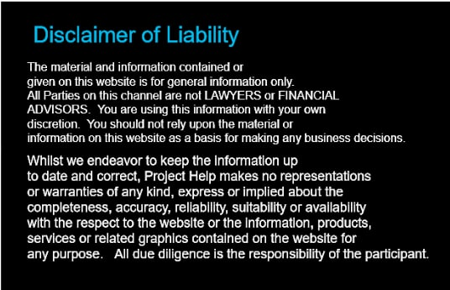

***Bank Accounts must have the following restrictions:***

1. Flag all accounts as “***ACCESS RESTRICTED TO NON-ESSENTIAL BANK PERSONEL***”
2. ***TAG ALL ACCOUNTS AS NON-TEST AND NON-TRANING ACCOUNTS***
3. Bank has ***NO POWER OF ATTORNEY***
4. Money Manager ***DOES NOT*** have complete fiduciary control over ANY of your money and must request authorization for any transaction as a security measure
5. Absolutely ***No Investing*** in Blackrock/Aladdin or Carlisle without approval and complete terms review

***Accounts must have the following features:***

1. NO Limitation of Time or Amounts, No Penalties, Charges or Fees on transfer or withdrawals of funds from any of the accounts
2. NO Fees on checking or savings accounts
3. NO ATM fees,
4. NO human teller fees
5. NO NON-System ATM fees
6. NO debit or credit card fees
7. NO Monthly Maintenance fee, Annual Maintenance fee, Service fee or Card fees for any purpose
8. NO fee or charge for cashing any form of checks, free traveler’s checks
9. NO Cash Advance fees
10. NO Automatic withdrawals
11. NO fees or charges for obtaining Certified Checks, Cashier’s Checks or Money Orders
12. NO fees for Bill Pay
13. NO Bank Spread or Currency Exchange fees
14. NO Cashier’s Checks fees
15. NO Annual Memberships fees
16. NO Computer or Remote Banking without ***Multifactor authentication*** to verify access and notification of all failed access attempts